Australia, the global renewable energy pathfinder
Andrew Blakers | Andrew.blakers@anu.edu.au | 0417 390 139
Ken Baldwin | kenneth.baldwin@anu.edu.au | 0432 987 251
Matthew Stocks | matthew.stocks@anu.edu.au | 0419 370 012
The Australian National University
3rd September 2020

Australia’s rapid deployment of renewable energy continues. According to the Clean Energy Regulator (CER), total additional delivered capacity of new solar photovoltaics and wind energy in 2020 will be around 6.3 GW, comprising 3.4 GW of utility scale wind and solar farms accredited and 2.9 GW of installed rooftop solar. This brings the total to 18 Gigawatts over 2018-20 and continues the trend of Australia’s world-leading per capita solar and wind deployment.
The new renewable energy capacity is strongly reducing greenhouse gas emissions in the electricity sector.
Importantly, increasing renewable energy deployment is compatible with low wholesale electricity prices. So far in 2020 53% of South Australia’s electricity came from renewable energy (solar and wind) compared with 100% in Tasmania (hydro and wind), 24% in Victoria, 15% in NSW and 14% in Queensland. So far in 2020, average wholesale electricity prices in South Australia have been similar to Queensland and below those in NSW and Victoria. Tasmania has the lowest prices. Australia is reducing emissions AND reducing electricity prices.
This good news is tempered by the urgent need for policy action to facilitate additional powerlines to efficiently bring the new solar and wind power to the cities.

Australia’s global leadership
Solar, wind and hydro comprise three quarters of global net annual capacity additions, with fossil and nuclear energy accounting for the remaining quarter. In Australia, solar PV and wind comprise 99% of new generation capacity because they are cheaper than fossil fuel additions.
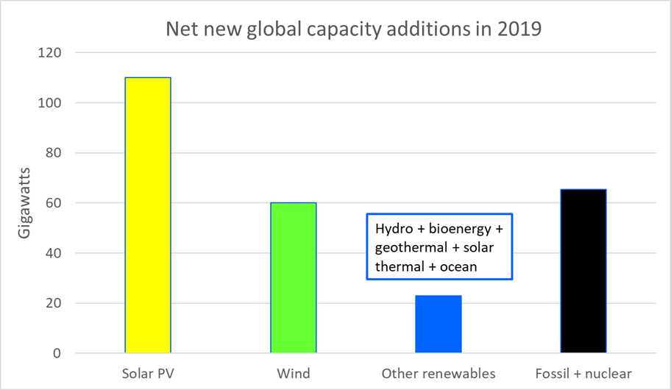
Figure 1: net new global generation capacity additions showing the dominance of solar and wind

Australia is leading the world in per capita deployment of solar and wind. In 2019, Australia deployed new renewable energy 10 times faster per capita than the global average and 4 times faster per capita than in Europe, China, Japan or the USA. Australia (per capita) has the most installed solar PV, the fastest deployment speed of solar PV and the fastest combined deployment speed of solar PV and wind.
The Australian experience is replicable in most other countries. Australia is a pathfinder for the three quarters of humanity who live in the sunbelt where most of the world’s growth in population, energy use and Greenhouse emissions are occurring.
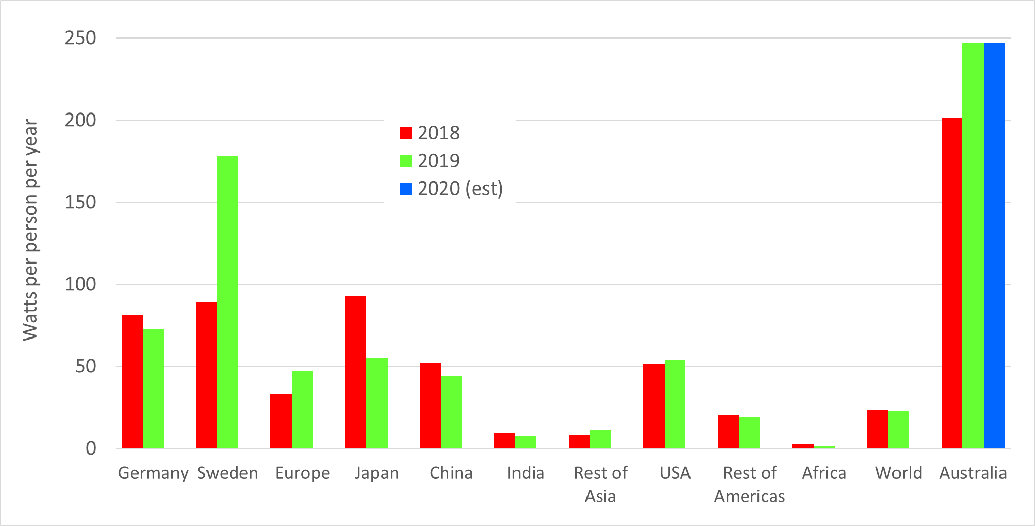
Figure 2: Deployment speed of PV and wind for 2018 (red) and 2019 (green) in terms of Watts per person per year [IRENA]. The estimate for Australia in 2020 (blue) from the Clean Energy Regulator is also included.

South Australia, with 53% generation from solar and wind is an important global exemplar of a rapid solar and wind energy transition. Few locations can match such a rapid and sustained growth in renewable energy.
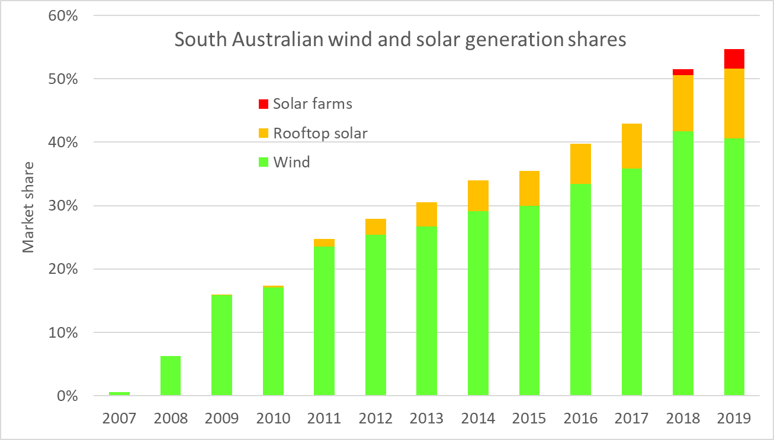
Figure 3: Solar and wind electricity generation in South Australia will reach 60% in 2020

Solar and wind in Australia
According to the CER, Australia is accrediting and deploying an average of 6 Gigawatts per year of new solar and wind energy over 2018-2020, which is 5 times faster than the years 2014-16. The CER expects the rooftop solar market to grow by 40% to 2.9 Gigawatts in 2020. According to the CER about 12 Gigawatts of rooftop solar has been installed, and nearly 30% of suitable dwellings have a rooftop solar system.
The CER reports that the pipeline of new wind and solar farm projects remains strong until at least 2022. On the one hand, deployment is being affected by lower prices for wholesale electricity, the attainment of the Renewable Energy Target and curtailment of output due to transmission bottlenecks. On the other hand, there are continually falling costs, deployment of solar and wind at mining projects, solar on commercial building rooftops, large-scale voluntary purchases of clean electricity and future retirement of coal power stations.
Stronger transmission is urgently needed to bring new solar and wind power to the cities. An effective way to do this is to upgrade transmission lines from rural Renewable Energy Zones to cities.
Governments have been slow to act on transmission. A determined effort by Federal and State Governments could resolve transmission bottlenecks by getting ahead of the solar and wind construction curve instead of lagging behind it!
The Australian Energy Market Operator’s 2020 Integrated System Plan is a guide to the changes needed in the electricity system to adapt to increasing levels of solar and wind power. The most ambitious scenario is called “Step Change” and envisages 90% renewable electricity by the late 2030s. However, Australia is installing about 6 Gigawatts of new solar PV and wind each year which already places us on the Step Change scenario path. It would therefore be prudent to model much more ambitious scenarios.
The renewable energy industry is a big business and growing. It already employs about 27,000 people and the financial value is around $8 billion per year, a significant fraction of which is spent within rural Australia on wind farms, solar farms, transmission and storage.
The renewable energy fraction of the National Electricity Market increased from 15.5% in 2017 to 22.3% in 2019 and is likely to rapidly increase in future years (Figure 4). This is causing coal generation to decline in the National Electricity Market. Continuing declines in the price of solar and wind may cause a wave of early coal generator retirements during the 2020s.
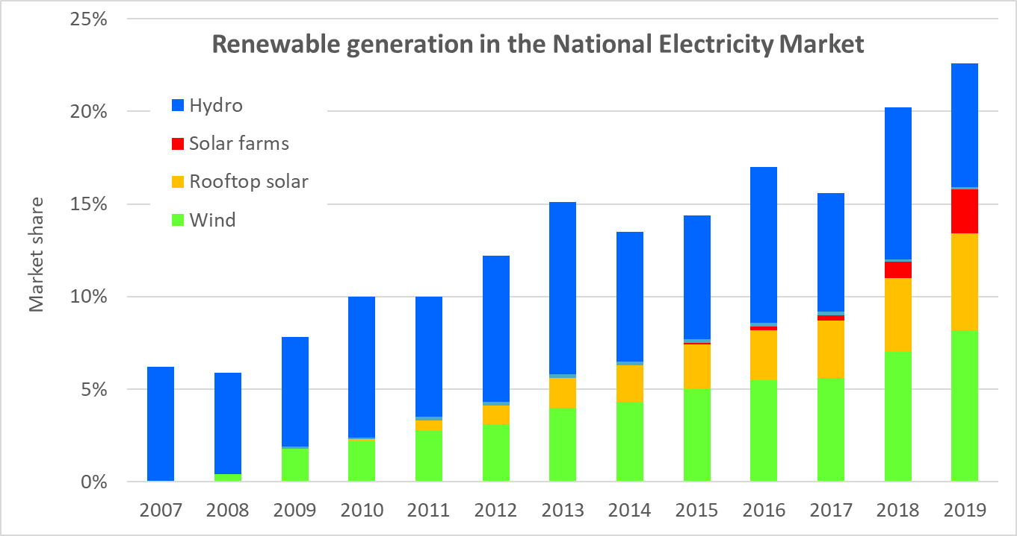
Figure 4: Renewable generation in the National Electricity Market will pass 26% in 2020

Balancing high levels of variable PV and wind is straightforward using off-the-shelf techniques: stronger long distance transmission (to smooth out variable local weather), storage (pumped hydro and batteries) and demand management. These techniques are being deployed at Gigawatt scale to manage Australia’s rapidly increasing PV and wind but more needs to be done.

Falling Greenhouse emissions
The National Greenhouse Gas Inventory shows that Australia’s overall Greenhouse emissions fell by 1.4% in the year to March 2020 (Figure 5). Emissions outside the electricity sector were static while electricity sector emissions fell by 4%. Renewables are now providing as much electricity to the NEM as gas and brown coal combined.

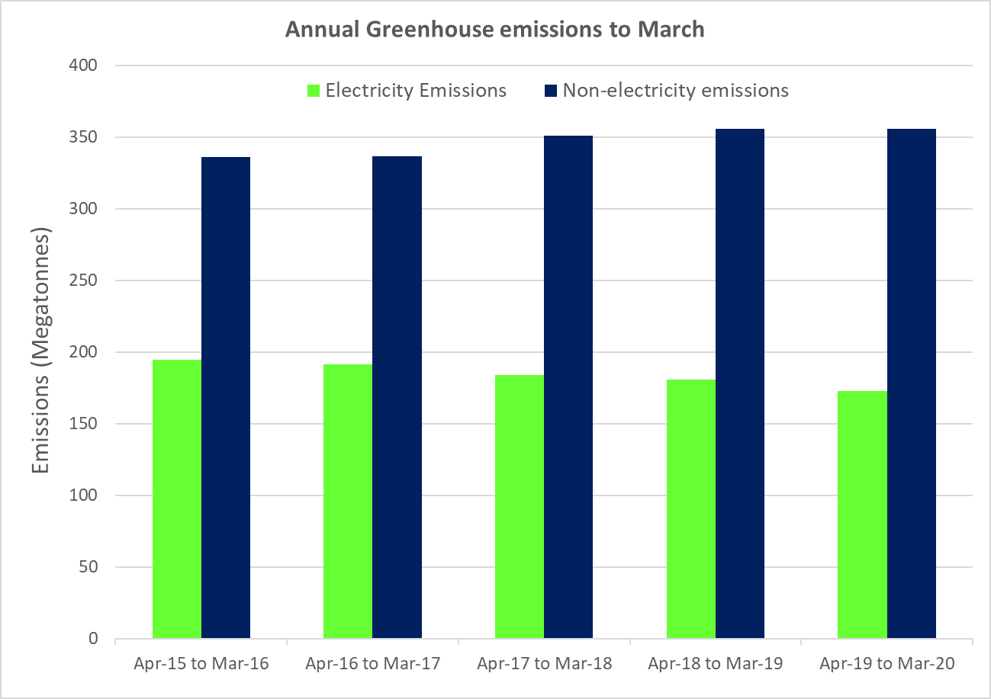
Figure 5: Australian annual emissions to March 2020 from electricity (green bars) and the non-electricity (blue bars) sectors. Overall, Australian emissions fell by 1.4% in the most recent year.

If new solar and wind energy systems continue to be deployed at a similar rate to 2019 and 2020 (6.3 Gigawatts per year), and if emissions in the non-electricity sectors grow at the slow rate predicted by the Federal Government, then under this scenario Australia is tracking to achieve its Paris emissions reduction target in 2030.
Solar and wind offer deep emissions reductions at low cost as they out-compete fossil fuel generation in the electricity sector. In the longer term, renewable electrification of transport, heating and industry can displace all fossil fuels from the Australian economy and thereby remove 85% of emissions. To reach this target by 2050 we calculate that Australia needs to double the annual deployment rate to 12 Gigawatts per year during the 2020s. This is not so hard considering that Australia quintupled its deployment rate since 2014-16.

The future
Australia has made immense contributions to global renewable energy and hence long-term climate action. This includes being the fastest per capita installer of solar and wind, Australia’s critical role in establishing the growth of PV manufacturing in China and Australia’s invention of the PERC silicon solar cell. Indeed, PERC solar modules are being deployed faster than the net new generation capacity of coal, oil, gas and nuclear combined.
The economics of PV and wind are compelling. Australia is demonstrating that rapid deployment of solar and wind can lead to declining emissions and low electricity prices. Now is the time to plan ahead to accelerate renewable deployment and decarbonize the entire economy.

